Landing Page:
Add product images on each card.
Make it static, because it won’t change often.
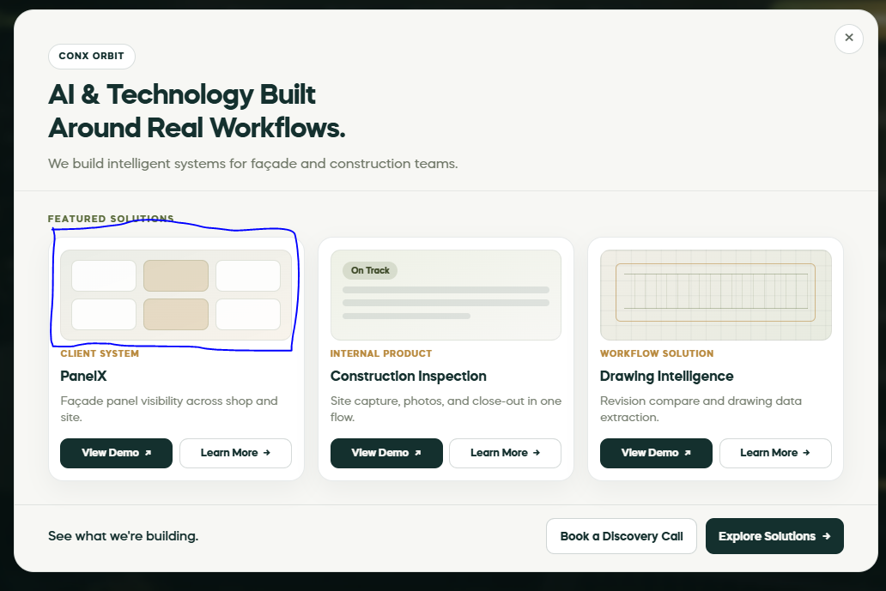
MAKE Problems in Red color and Make solutions in green color. Make the color of tic
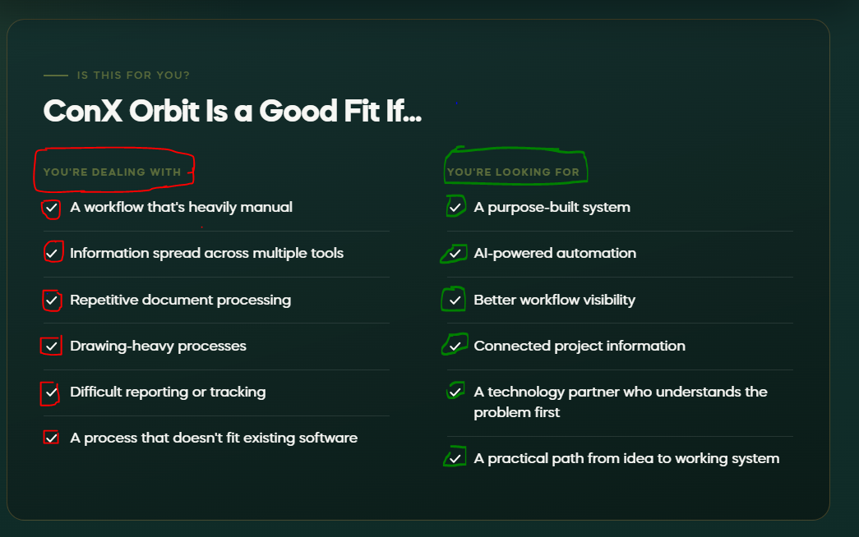

Case Study Page:
For each Case study, show this information:
Hero section:
At the top:
CASE STUDY – Client System (category of solution)
Name of Solution:
PanelX
Solution heading:
Façade Intelligence Platform
Short Summary:
A web-based platform built to connect façade drawings, panel information, documentation and field reporting in one workflow.
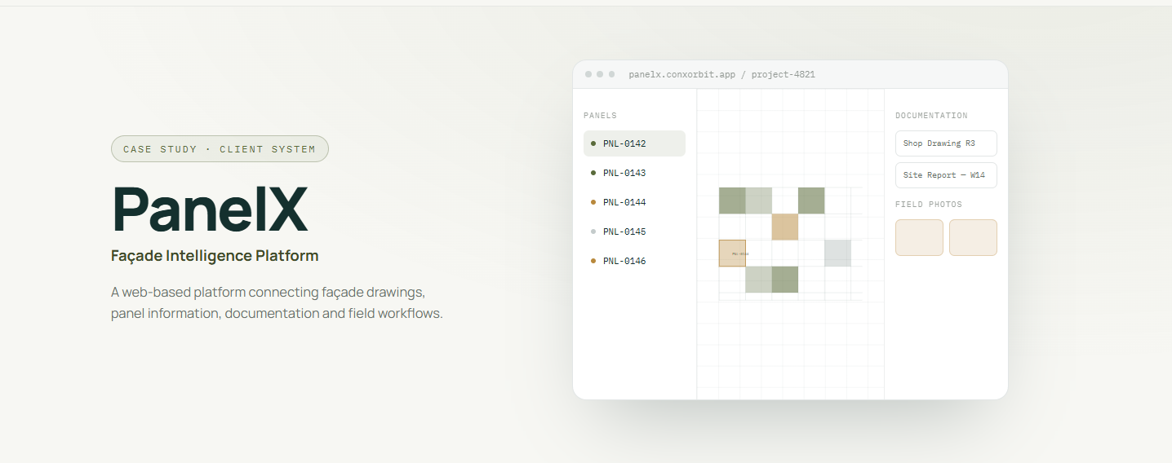
Problem Section:
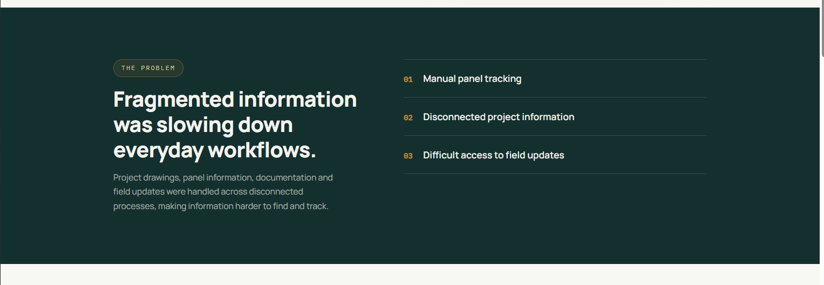
Solution Section:
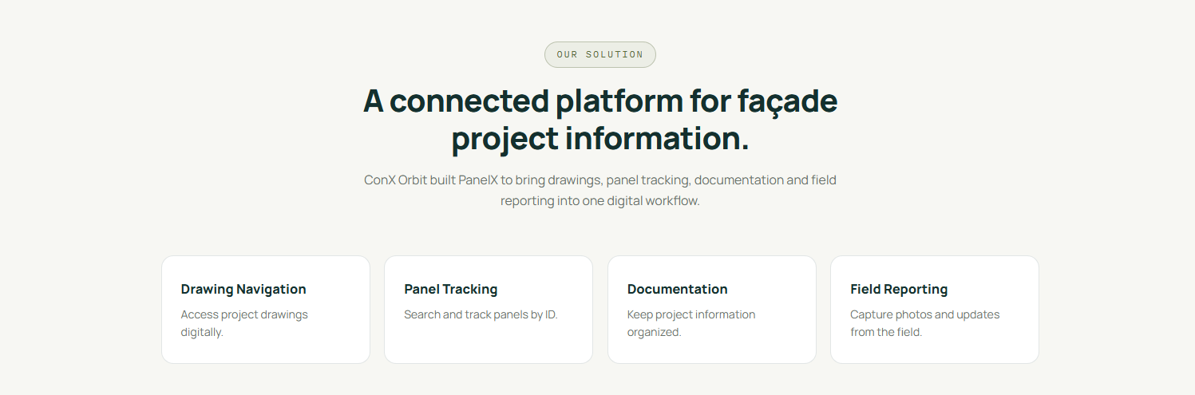
CTA:
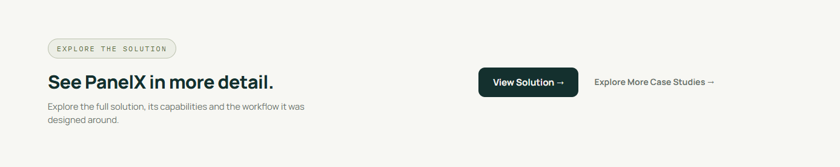
Database fields:
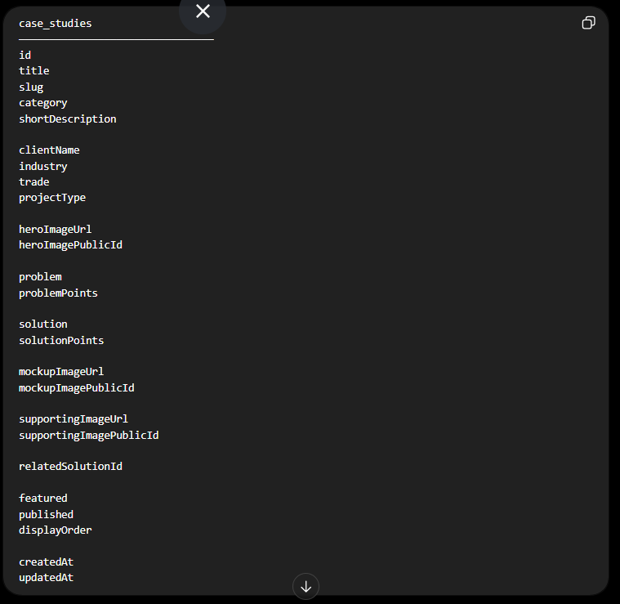
2-Problem points: Store them as Array like the example below:
Database field:
field name: problemPoints
Field type: JSON / JSONB

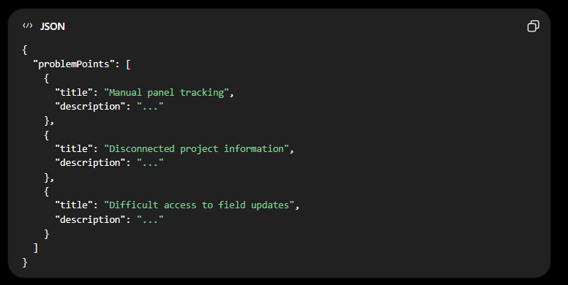
3- Solution Points:
Same, store them as Array.
Database field:
field name: solutionPoints
Field type: JSONB
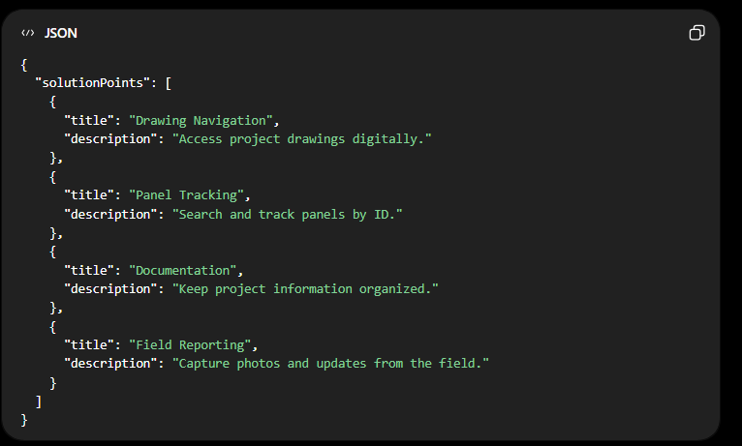

Admin Portal Changes:
Make listing badge as dropdown:
Dropdown options:
- Client system
- Internal Product
- Workflow Solutions
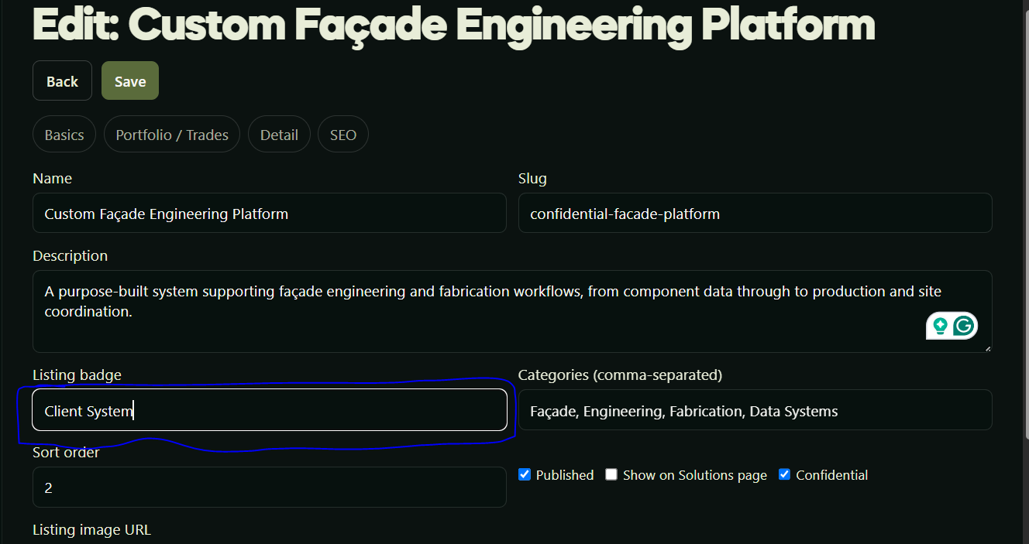

Note: Anything that has pre-defined options, show them as dropdown rather than manual text entry.

